PickeMe is a digital solutions company that operates predominantly in ride-hailing (75% expected revenue), Delivery, and Experiences (currently through “events”) Ride-hailing is a sub-industry of the Passenger Ground Transportation (PGT) industry. PickMe has expanded its services into other industries, leading it to be a super app stepping by into Technology and Logistics. Therefore, the competitive positioning is done based on Ride- Hailing, Technology, and Logistics.

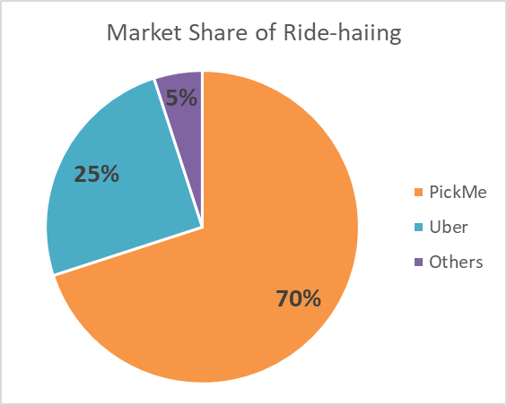
PickMe is the market leader in the duopoly in Ride-hailing
The current Sri Lankan ride-hailing industry is a duopoly dominated by Pickme (70% market share), followed by Uber (25% market share), and many others (less than 5%) (YoGo, Kangaroo cabs, HelaGo, Jride, CanGo, etc.) PickMe, the local pioneer, reported over 1.34 million unique riders, 100,000+ active drivers, and 4,500+ merchant partners. Its operations span 14 districts, dominating urban areas such as Colombo, Gampaha, Kurunegala, Kandy, Kalutara, and Galle. Despite being the market leader, only around 8% of the total population and less than 12% of adults have used ride-hailing at least once, indicating significant room for market growth.
Uber, although an international brand, has a smaller presence, primarily concentrated in Colombo and a few other urban centers. The strong network effect of PickMe gives it a competitive advantage as more users attract more drivers, and a larger driver base attracts more users. Other competitors have limited influence on market share.
However, in the food delivery vertical, Uber has a higher market share.

High competition from rivals and substitutes
Given that PickMe is the ride-hailing leader in Sri Lanka, it faces high competition from traditional alternatives and substitutes than direct rivals. Sri Lanka has a strong public transport culture and offers the cheapest transport options. It has been a part of people’s lives and living culture. On the other hand, owning a private vehicle is seen to be a way to show one’s social status. Therefore substitutes for ride hailing as buses, trains, tuk-tuks, and even private vehicles dominate commuting. Many people only use ride-hailing for convenience (urban areas, emergencies, late nights). This makes substitutes very accessible, giving buyers high bargaining power. In 2023, motorcycles made up about 58% of Sri Lanka’s vehicle population, but fewer than 0.49% are used on ride-hailing platforms. In 2022, three-wheelers alone have reported nearly 25% of passenger transport, up from 19.5% in 2019. Only 4% of the Tuk tuks are penetrated by PickMe leaving the rest as direct competitors. Every non penetrated vehicle is a substitute.

Looking at other verticals of pickme, such as pickme foods, flash, courier, events, they provide an interdemiray platform for services that already operate on their own. This makes services offered by PickMe relatively more expensive due to the commission rates.While Uber dominates food delivery (~60% market share) many customers still opt for direct store delivery as it is most likely to be relatively cheaper. Most businesses use courier service providers to courier their products to customers as the cost is predictable and relatively cheaper. Looking at the new vertical introduces, events, there are many existing platforms which offer these services.

All-in-one app to create customer loyalty
Customers are not loyal and price sensitive
The main services offered by Pickme are largely undifferentiated from its close competitors. People who can afford these services generally aren't loyal, as the services are undifferentiated. Most customers are highly price-sensitive and prioritize availability, speed, and cost over brand allegiance. As a result, customers frequently switch between apps to compare prices and availability with zero switching cost. Beyond app-to-app switching, riders can also shift to public transport (buses, trains) or other private transport modes (traditional taxis, three-wheelers hailed off the road) with minimal effort.

High network and financial growth allow them to explore
PickMe’s larger user base and network have allowed them to cater to the mass market than focusing on a niche market. Most of the minor players in the market try to differentiate themselves through specializing in something. (eg - Ceylon Tax- Airport pickups and long distance tours, Kangaroo - more reliable transport, Van uncle - Office transport , Yogo - GPS-enabled smart meter, Lady for a Lady) The large network PickMe has built along with its financial growth aided by business growth has allowed them to diversify into a multi-service platform offering food delivery, parcel delivery, on-demand trucking, and most recently experiences (events) in addition to ride-hailing. Therefore, the strategy PickMe uses to gain a competitive edge and customer loyalty is to be a platform that brings all of these services together and offer it them in one app.

